**Experiment 11**

**QUALITATIVE ANALYSIS**

**SALT NO.9 [SrCl 2]**

**Aim**: Analyse the given salt for acidic and basic radicals.

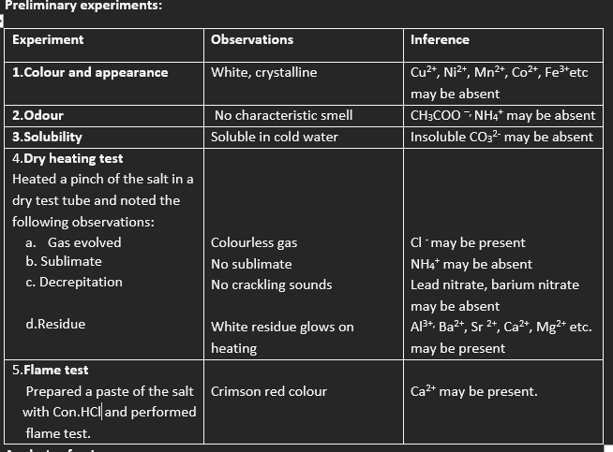

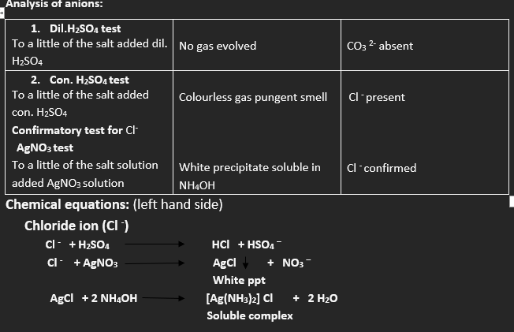

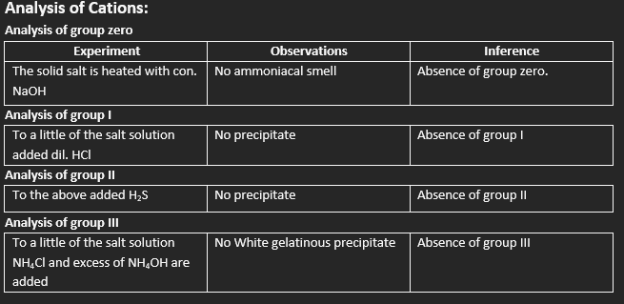

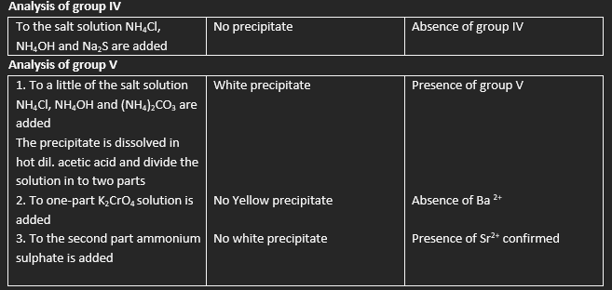

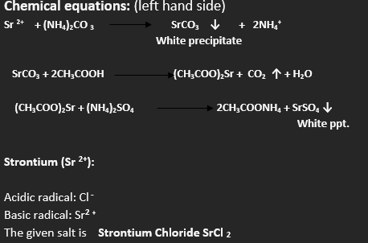

**Experiment 12**

**QUALITATIVE ANALYSIS**

**SALT NO.10 [Ba (NO3) 2]**

**Aim**: Analyse the given salt for acidic and basic radicals.

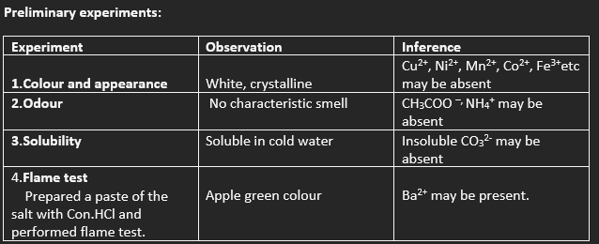

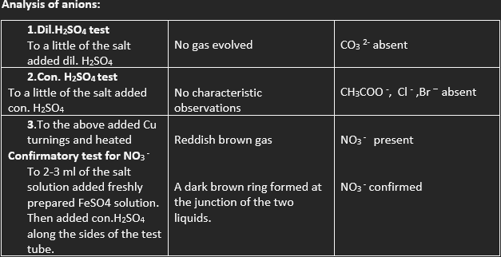

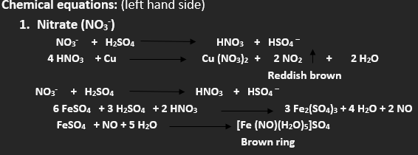

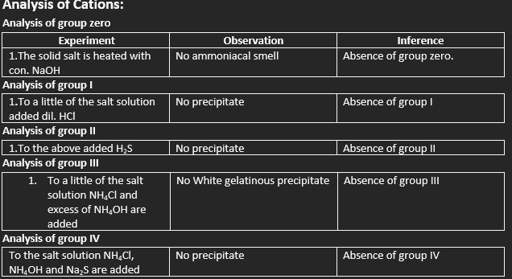

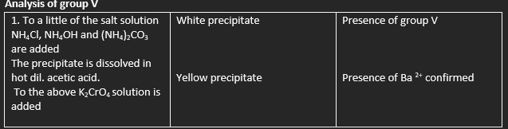

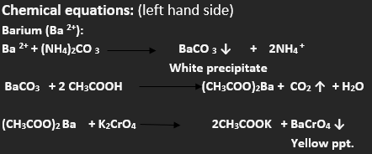

**RESULT:**

Acidic radical: NO3 **-**

Basic radical: **Ba2 +**

The given salt is **Barium nitrate Ba (NO3)2**